Dilhara Ishini Wickramasinghe
Musaeus College
grade 9J
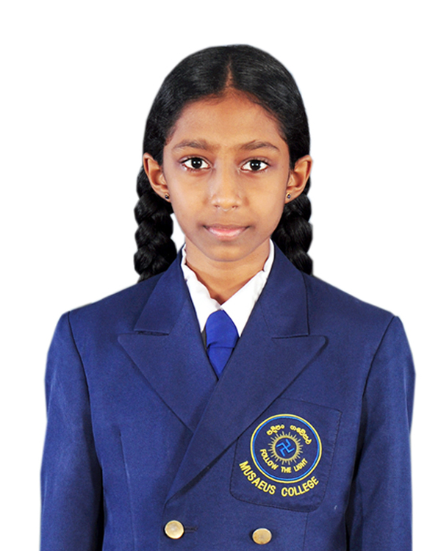
Awards from National And International chess events
2014 Since the National Youth Champion under 14 girls at the National Youth Chess Championship 2014 (held Sri Lanka by Chess Federation of Sri Lanka) and qualified to represent Sri Lanka at World Youth Chess Championship 2014 Durban , South Africa from 18 sep to 30th sep 2014 and

Asian Youth Chess Championship will be held in New Delhi from 6-November to 13-November 2014.

2014 Since the Equal Fist under 15 girls , at All island schools Individual chess Championship 2014 held in Sri Lanka By Schools Chess Association and qualified to represent Sri Lanka (under 15 girls) at the World Schools Chess Championship will be held in Brazil from 26 November to 4 December 2014 and 10th Asian Schools Chess Championship 2014 will be held in Taichung , Taiwan from 23rd August to 30th August 2014 .

2013 Since Champion at Sri Lanka All island schools Individual Chess Championship 2013 and represented Sri Lanka in Asian Schools Chess Championship held Hikkaduwa Sri Lanka won 1st runners up with the silver medal With Women’s Candidate Master Title (WCM).

2013 - Since Sri Lanka Champion Under 13 girls Sri Lanka super Thirty (11) organized by School Chess Association of Sri Lanka, qualified to represent Sri Lanka as the official player at the 9th World Schools Chess Champion ship 2013 held in Greece 6th May to 15th May 2013.

2012- Since Sri Lanka Champion Under 13 girls Sri Lanka super Thirty (1) organized by School Chess Association of Sri Lanka, qualified to represent Sri Lanka as the official player at the 8th Asian Schools Chess Champion ship 2012 held in India New Delhi December 14 to 21st 2012.

2012 – Since Champion in u13 age category she represented Sri Lanka For 8th world schools chess championship held in Romania in April 2012 and ranked world no. 20 in the under 13 age category.

2012 – Equal First- National Youth Chess Championship organized by chess Federation Sri Lanka Qualify to represent Sri Lanka and participated at the World Youth Chess Championships Maribor 2012 conducted by World Chess Federation held in Slovenia Maribor in November 7-19 year 2012 and manage to won 6 games.

2012 Since Champion - Asian Youth Chess Championship 2012 - Chess Federation of Sri Lanka on Behalf of Asian Chess Federation Under 12 category.

2011- World Schools Chess Selection Tournament – champion

Past international events held in Sri Lanka

2014 Champion Under 15 age category Colombo open Chess Championship 2014
2014 Champion Under 15 age category 4th Damso International Chess Championship 2014
2014 Equal Third Best Women’s category at 7th Colombo international chess Championship 2014
2013 3rd place 6th Colombo international chess Championship 2013
2013 Women’s National A team player (9th) Place in 2013
2012 - 1st Place “BUDDHI” 3rd Open Inter national Rating Chess Championship 2012
2012 – 1st Place COLOMBO INTERNATIONAL 5th CHESS FESTIVAL 2012
2012 1st Place Sri Lanka Open International Rating Chess Championship 2012
2012 Equal 1st Place Mora Kings 5th International Rating Chess Championship2012
2011 - 2nd Place 64 squire 2nd International Rating Chess Championship 2011
2011 1st Place Open International Rating 4th Chess Championship 2011
2011 1st Place Mora Kings 4th International Rating Chess Championship2011
2011 1st Place Ethugalpura 3rd International Rating Chess Championship 2011
2010 - Equal 3rd place “BUDDHI” Open International Rating Chess Championship 2010
2010 – 1st Place Ethugalpura 2nd International Rating Chess Championship 2010

